

**oneM2M Browser**

**Software Version: 1.0.3.5**

**-Base on mobius-yt-r2-2.4.1**

**User Guide v1.2**

Document Release Date: July 11, 2017  
Software Release Date: July 11, 2017

Copyright (c) 2014, OCEAN

All rights reserved.

Redistribution and use in source and binary forms, with or without modification, are permitted provided that the following conditions are met:

1. Redistributions of source code must retain the above copyright notice, this list of conditions and the following disclaimer.

2. Redistributions in binary form must reproduce the above copyright notice, this list of conditions and the following disclaimer in the documentation and/or other materials provided with the distribution.

3. The name of the author may not be used to endorse or promote products derived from this software without specific prior written permission.

THIS SOFTWARE IS PROVIDED BY THE AUTHOR ``AS IS'' AND ANY EXPRESS OR IMPLIED WARRANTIES, INCLUDING, BUT NOT LIMITED TO, THE IMPLIED WARRANTIES OF MERCHANTABILITY AND FITNESS FOR A PARTICULAR PURPOSE ARE DISCLAIMED. IN NO EVENT SHALL THE AUTHOR BE LIABLE FOR ANY DIRECT, INDIRECT, INCIDENTAL, SPECIAL, EXEMPLARY, OR CONSEQUENTIAL DAMAGES (INCLUDING, BUT NOT LIMITED TO, PROCUREMENT OF SUBSTITUTE GOODS OR SERVICES; LOSS OF USE, DATA, OR PROFITS; OR BUSINESS INTERRUPTION) HOWEVER CAUSED AND ON ANY THEORY OF LIABILITY, WHETHER IN CONTRACT, STRICT LIABILITY, OR TORT (INCLUDING NEGLIGENCE OR OTHERWISE) ARISING IN ANY WAY OUT OF THE USE OF THIS SOFTWARE, EVEN IF ADVISED OF THE POSSIBILITY OF SUCH DAMAGE.

Contents

1. Introduction 4

1.1. What is oneM2MBrowser 4

1.2. Supported platform 4

1.3. oneM2M Browser function 5

2. Architecture 5

2.1. System Architecture 5

2.2. Software Architecture 6

1. Introduction
   1. What is oneM2MBrowser

oneM2MBrowser is a tool for monitoring the oneM2M resources in the Mobius Yellow Turtle([Mobius-yt](https://github.com/IoTKETI/Mobius)). It is working base on oneM2M HTTP RESTful API and MQTT Message. It was designed for helping developer to easily work with Mobius-yt.

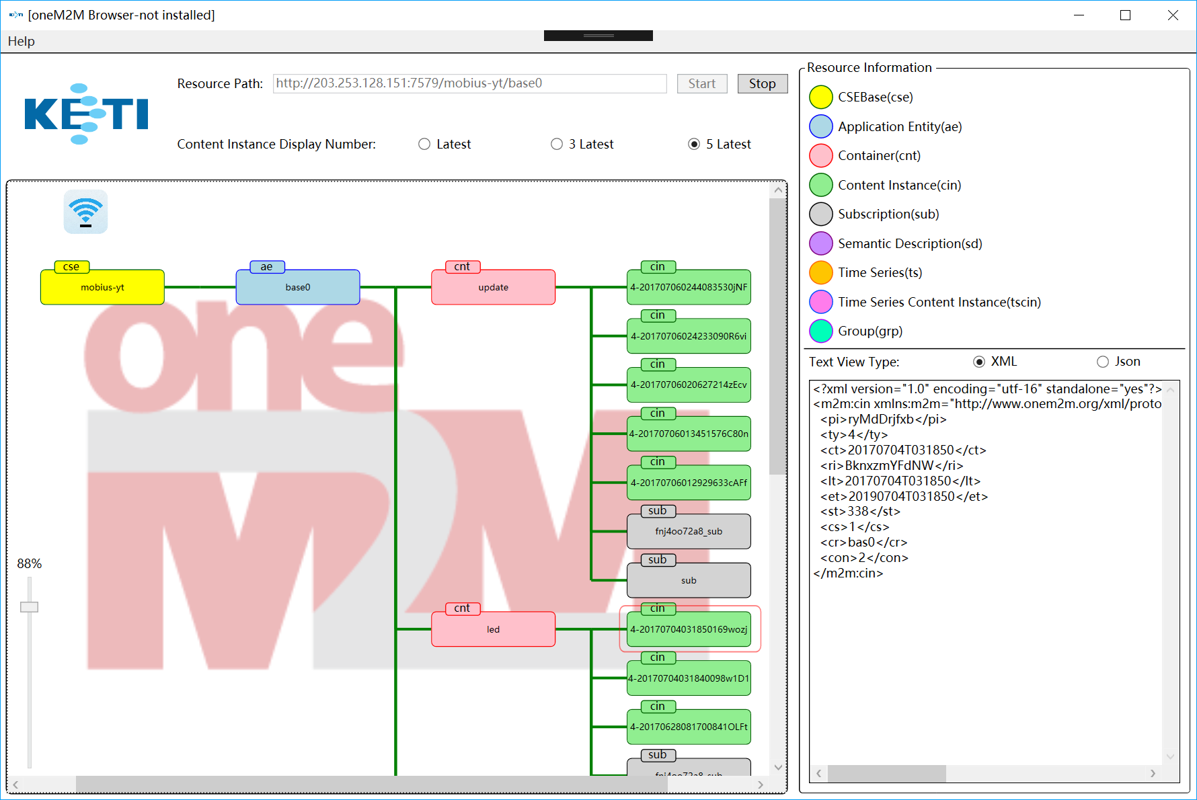

Figure 1 oneM2M Browser

* 1. Supported platform

It only works on Windows OS (windows XP, Vista, 7, 8, 10) and it also require the OS must be installed the .NET Framework.

* 1. oneM2M Browser function

1. Display the oneM2M resource as tree.
2. Retrieve the resource information.
3. Create new resource.
4. Real-time monitoring resource (delete, create).
5. Architecture
   1. System Architecture

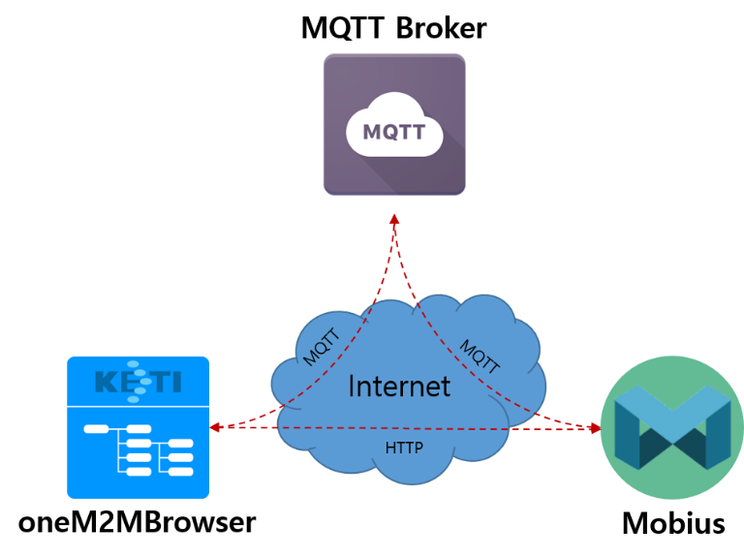

Figure 2 System Architecture

The oneM2MBrowser connects with Mobius IoT Server Platform and MQTT Broker. Mobius is a kind of IoT Server Platform collection all oneM2M(IoT Standard) Resources and provides a set of open API which binding with HTTP, COAP, MQTT protocol for managing resource inside. In oneM2MBrowser case, it retrieves the resource structure by discovery API and display it as GUI and create subscription for necessary resources for receiving resource creating or deleting notification message.

* 1. Software Architecture

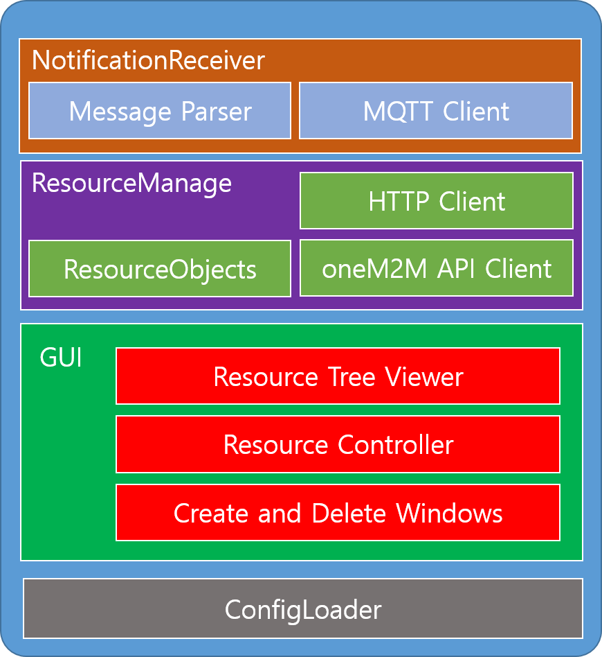

Figure 3 software Architecture

The oneM2MBrowser architecture can be divided into four big modules. "NotificationReceiver" can receive MQTT notification message and parse it then add or delete matched resource in "ResourceManager". "ResourceManager" provide a series of oneM2M API accessing function and it can discovery Mobius inside resource structure by these API then store it in the memory as objects. "GUI" provides some windows and dialogs for user interaction. "ConfigLoader" is used to store local application parameter.

1. Development Environment
   1. Download Source

Download the source file from [oneM2MBrowser github site](https://github.com/IoTKETI/oneM2MBrowser):

<https://github.com/IoTKETI/oneM2MBrowser>

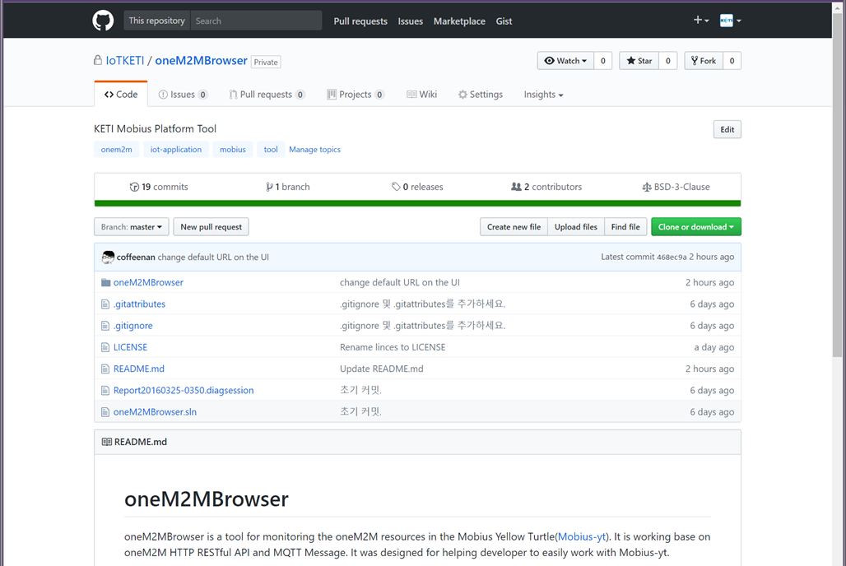

Figure 4 oneM2M Browser GitHub site

* 1. Development Tool

The oneM2MBrowser project is a Vistual Studio project. So, it only can work on window PC. If you don't have the winPC that we suggest to insall the [VMware WorkStation Player](https://www.vmware.com/products/player/playerpro-evaluation.html) and run a Virtrual Machine on it.

1. Download the [Visual Studio](https://www.visualstudio.com/).
2. Install the Visual Studio follow the guide.
3. Open the oneM2MBrowser home and double click oneM2MBrowser.sln file.
   1. Execution

Press the F5 key in Visual Studio click the start button on top of Visual Studio IDE.